# XMLReader – SRS

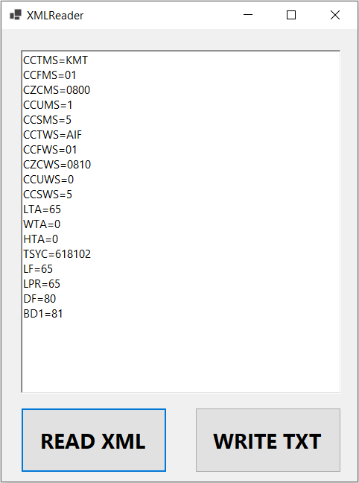

Open the “XMLReader.sln”

Use the “READ XML” button for opening of the **file browse dialog** and loading of the “INPUT.xml” file and fetch all the values from the “Characteristic System”-node.

**Show all the child node IDs and values in your Form.**

You can use a table, a grid view, or just a RichTextBox.

Use the button “WRITE TXT” to open the **directory browse dialog** and save all the child node names and values into this text file.

The result should look like in the OUTPUT.txt file:

CCTMS=KMT

CCFMS=01

CZCMS=0800

CCUMS=1

CZCWS=0810

…

…

…